**Linux Commands**

Following are some basic Linux commands :

1. **date :** It displays both the date and the time.

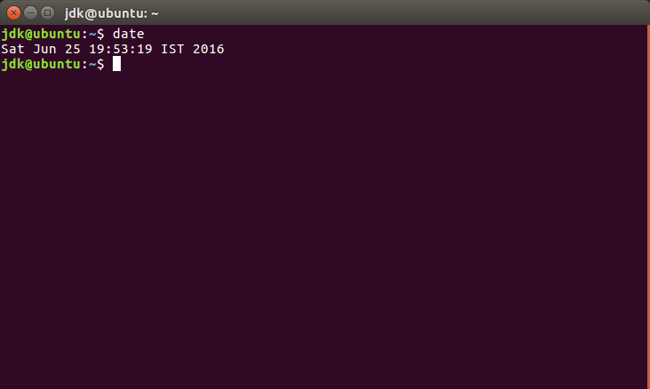

2. **tput clear :** It is used to clear the screen.

3. **cal :** It is used to see the calendar of any specific month, or a complete year.

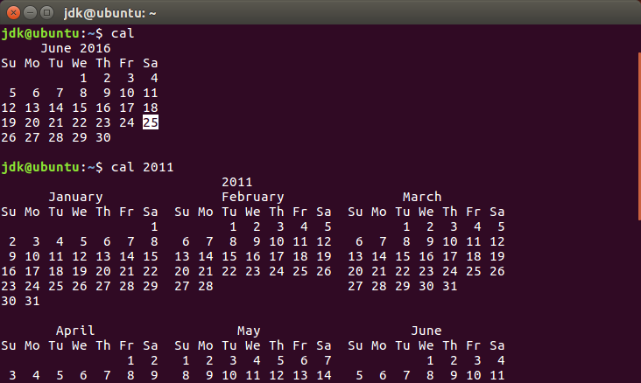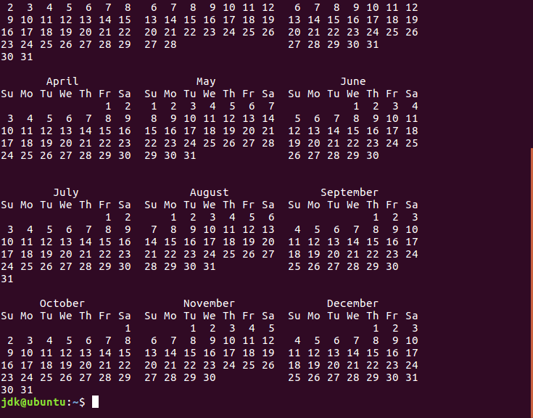



4. **who :** It gives all users using the system.

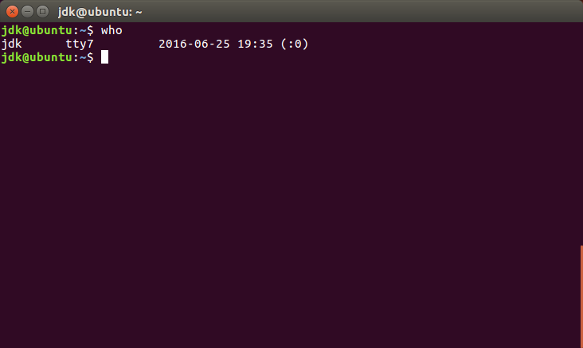

5. **ls : Listing Files -** It lists the names of all the files available in the current directory.

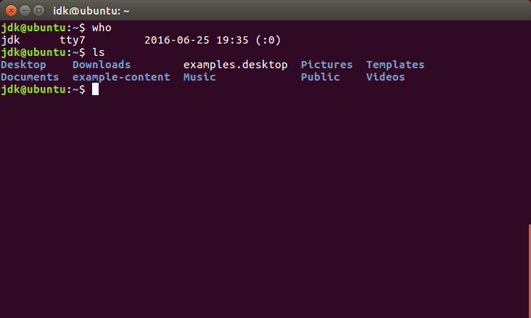

6. **ls –l :** This lists the names of all the files in the current directory along with some of their major attributes.

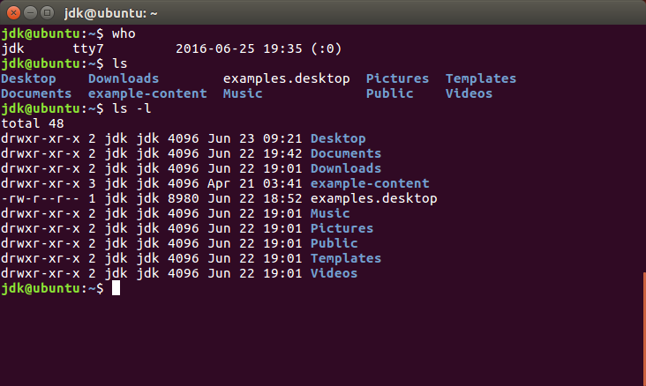

7. **nano, cat :** nano is used to create a new file and cat command gives the output of the given file.

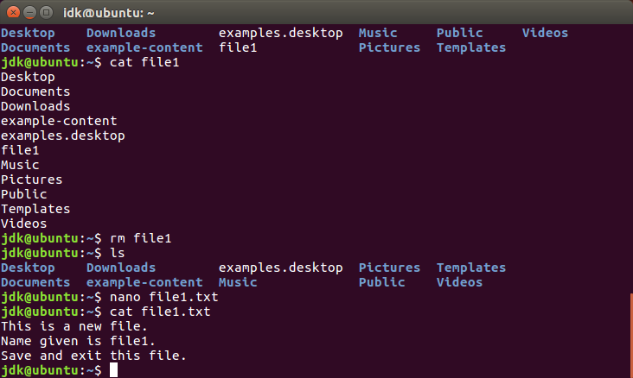

8. **wc :** It gives the number of lines, words and byte count for each file

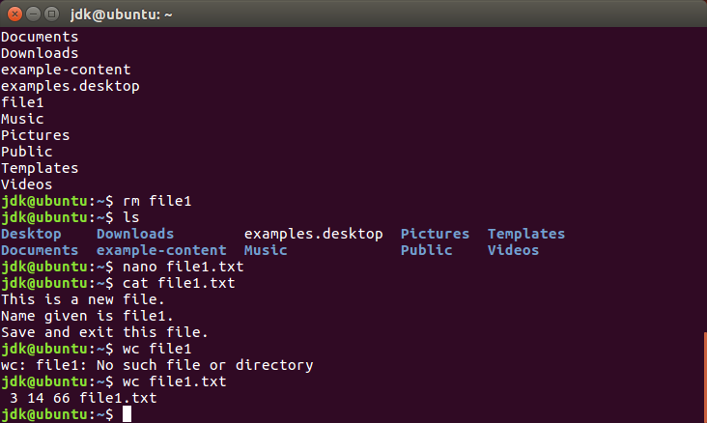

9. **echo :** It evaluates the value of a variable.

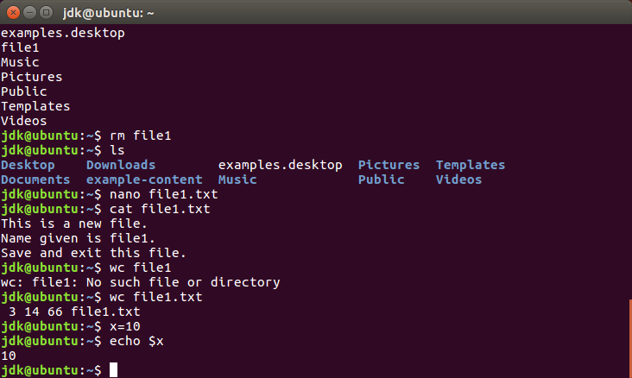

10. **man :** man command is an on-line help facility that is provided by the operating system.

Eg. man echo

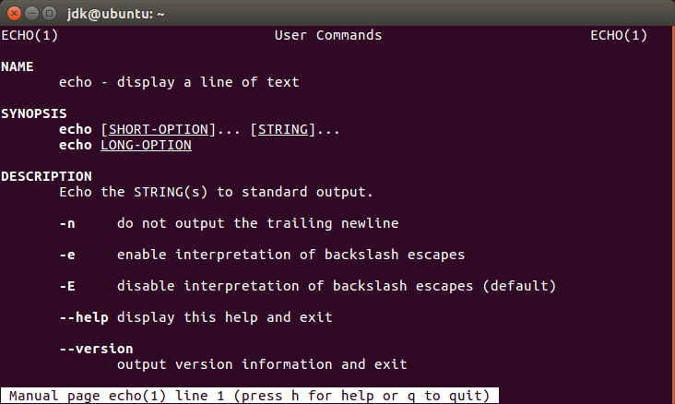

11. **pwd : Print working directory –** It gives the current directory.

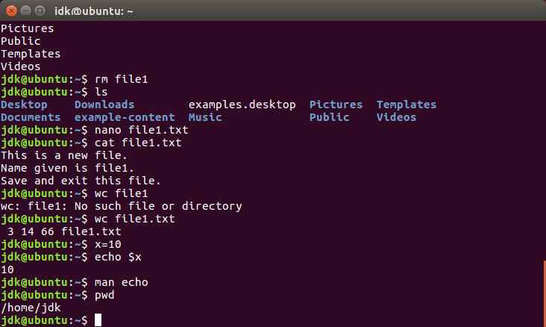

12. **cd : Change directory –** It changes the directory to the directory specified as the argument given in the command.

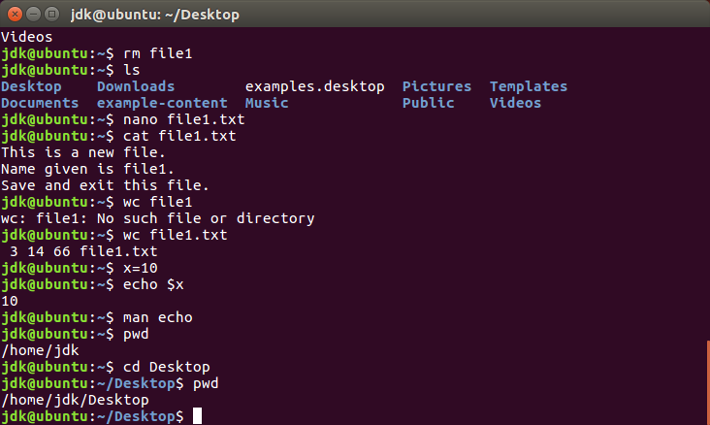

13. **mkdir : Make directory –** A new directory is created by this command. Multiple directories can also be created using this command.

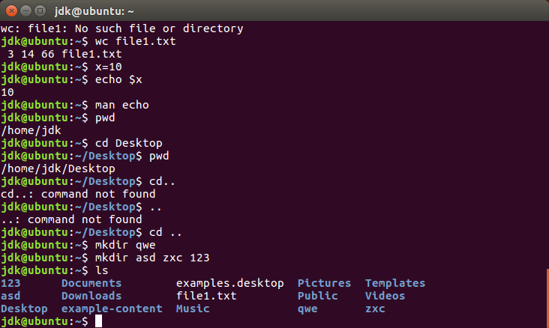

14. **rmdir : Remove directory –** Existing directories can be deleted using this command.

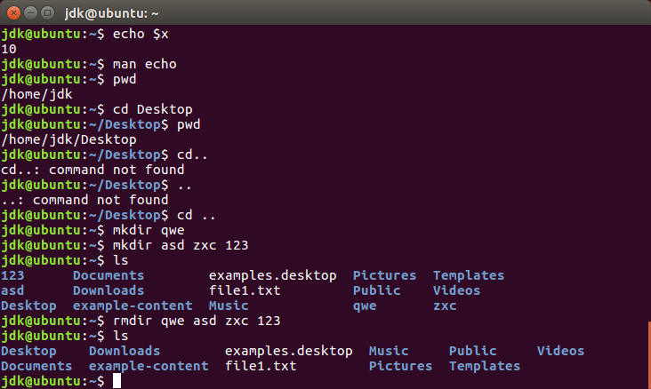

15. **adduser :** This command is used to add a new user in the operating system.

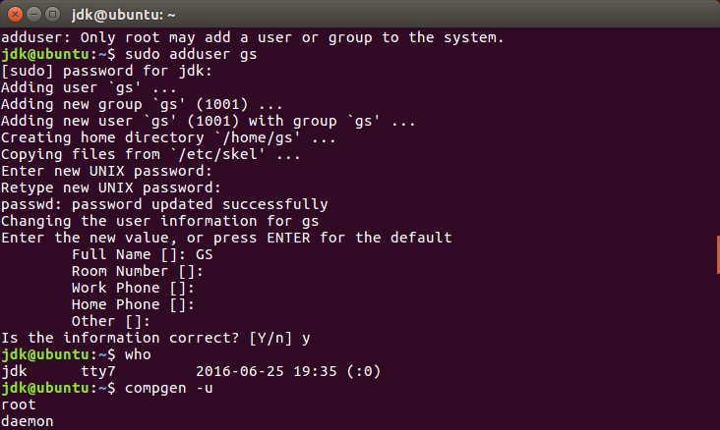

16. **userdel :** It deletes an excisting user that is specified with it.

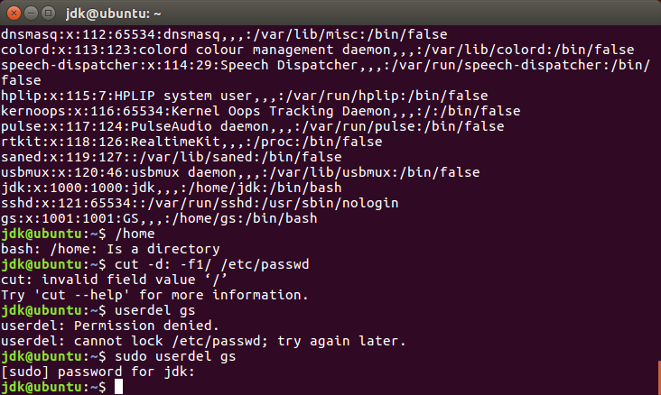

17. **du : Disk usage –** It reports the current disk usage bya a recursive examination of the directory tree. By default, du lists the usage of each subdirectory of its argument, anf finally produces a summary.

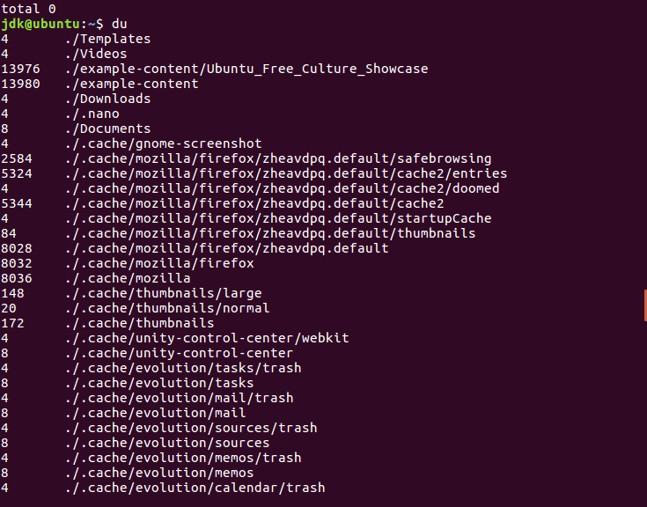



18. **head :** It displays the top of the file. When used withput an option, it displays the first ten lines of the file.

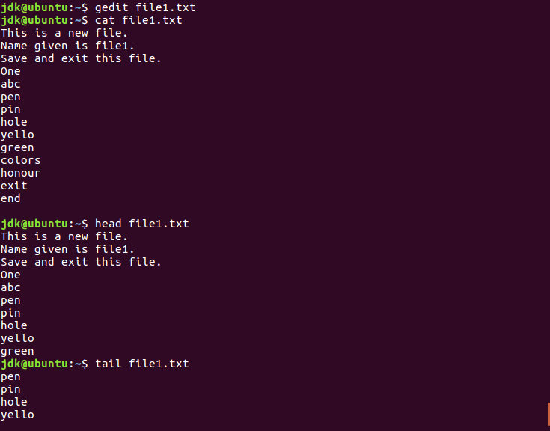

19. **tail :** It displays the end of the file. It provides an additional method of addressing lines. And displays the last ten lines of the file when used without arguments.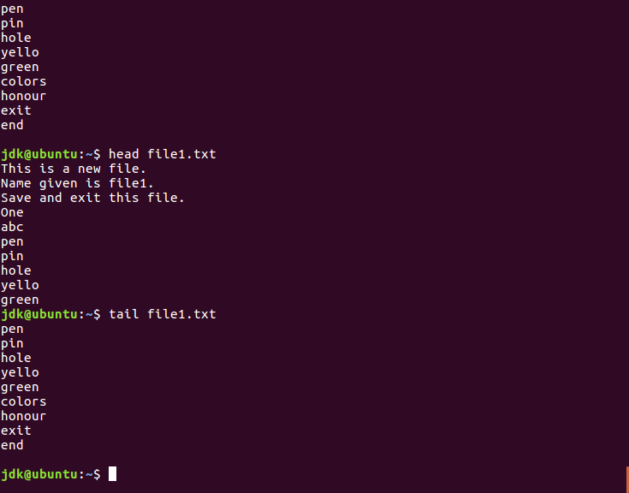

20. **mv : Move –** This command is used to move a file from one location to another.

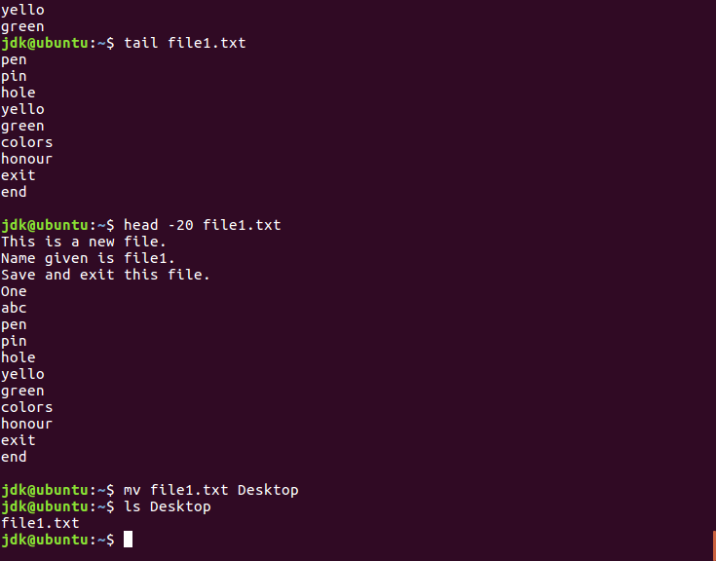

21.  **cp : Copy –** It is used to copy the contents from one place to another.

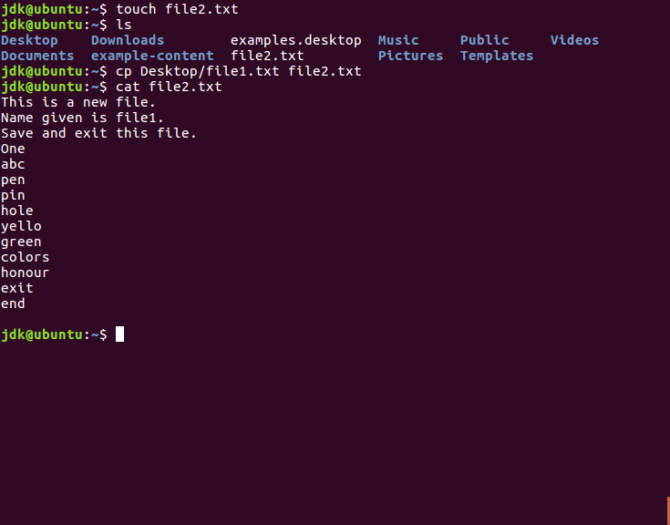

22. **ps : Process status –** It displays the processes associated with a user at the terminal. It can be seen as the process counterpart of the file system’s ls command.

